

Supply Agreement

Harbor Lane Provisions and Northwind Coffee Roasters

1. Parties
Buyer: Harbor Lane Provisions, 18 Quayside Road, Port Ellery, represented by Lena Park, Procurement Lead.
Supplier: Northwind Coffee Roasters, 4 Roastery Lane, Millbrook, represented by Alex Chen.
This agreement takes effect on 12 January 2026 and replaces the agreement of January 2023.

2. Products
The Supplier roasts and delivers the following coffees to the Buyer's Quayside warehouse:
- Harbor Blend whole bean coffee, 1 kg bags
- Dockside Decaf whole bean coffee, 1 kg bags
- Lighthouse Espresso beans, 1 kg bags
- Cold brew concentrate, 1 L bottles
- Autumn Harvest spiced roast, 500 g bags (September to December)

2.1 Autumn Harvest allocation
For each harvest season the Supplier reserves 2,400 kg of the spiced roast for the Buyer. Unordered volume is released on 15 October.
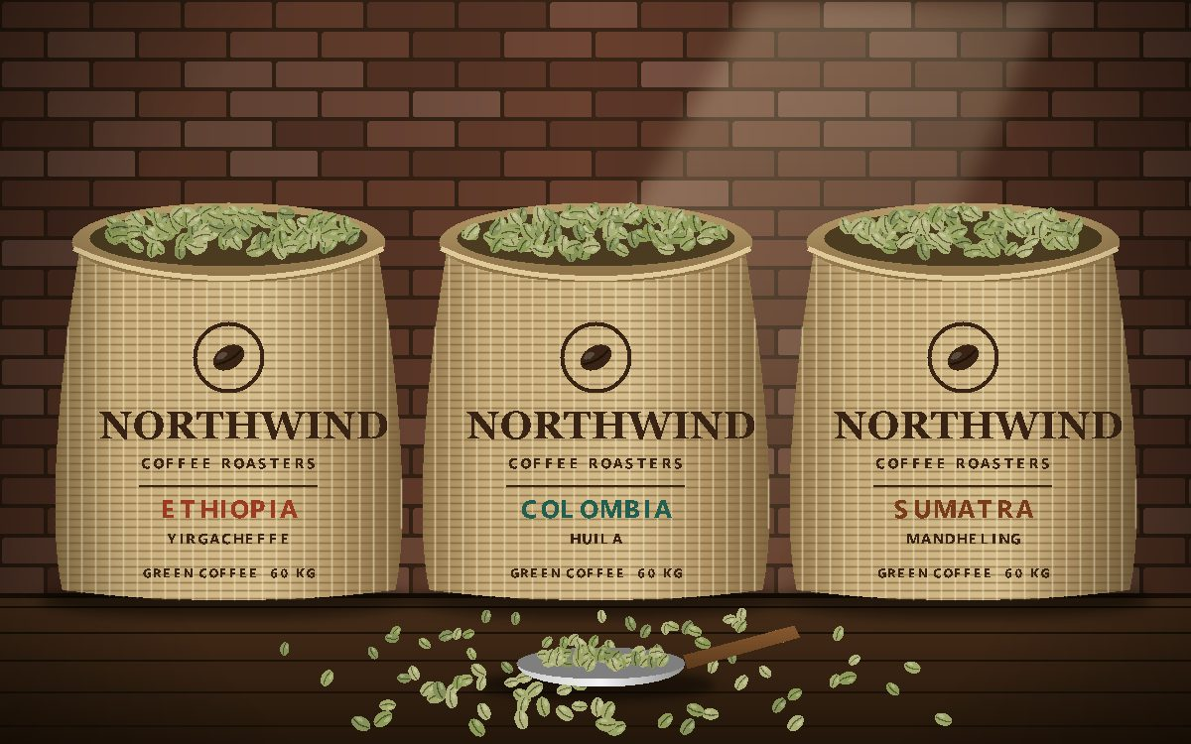

3. Prices and fees
Prices are per unit, delivered, excluding sales tax, and fixed until 31 December 2026.
Product | Unit | Price | Minimum order
Harbor Blend | 1 kg bag | $18.40 | 40 bags
Dockside Decaf | 1 kg bag | $19.10 | 20 bags
Lighthouse Espresso | 1 kg bag | $21.75 | 30 bags
Cold brew concentrate | 1 L bottle | $9.60 | 24 bottles
Autumn Harvest spiced roast | 500 g bag | $11.20 | 50 bags

3.1 Price review
Either party may ask for a price review once a year, with 60 days' notice, if green coffee prices move by more than 12%.

4. Delivery
- Deliveries arrive on Tuesdays and Fridays between 06:00 and 10:00.
- Coffee is roasted no more than five days before delivery.
- The Buyer confirms each delivery against the order within one working day.

5. Quality and audits
The Supplier follows the Buyer's supplier quality charter and publishes its sourcing data at northwindroasters.example/quality. The Buyer may audit the roastery once a year.
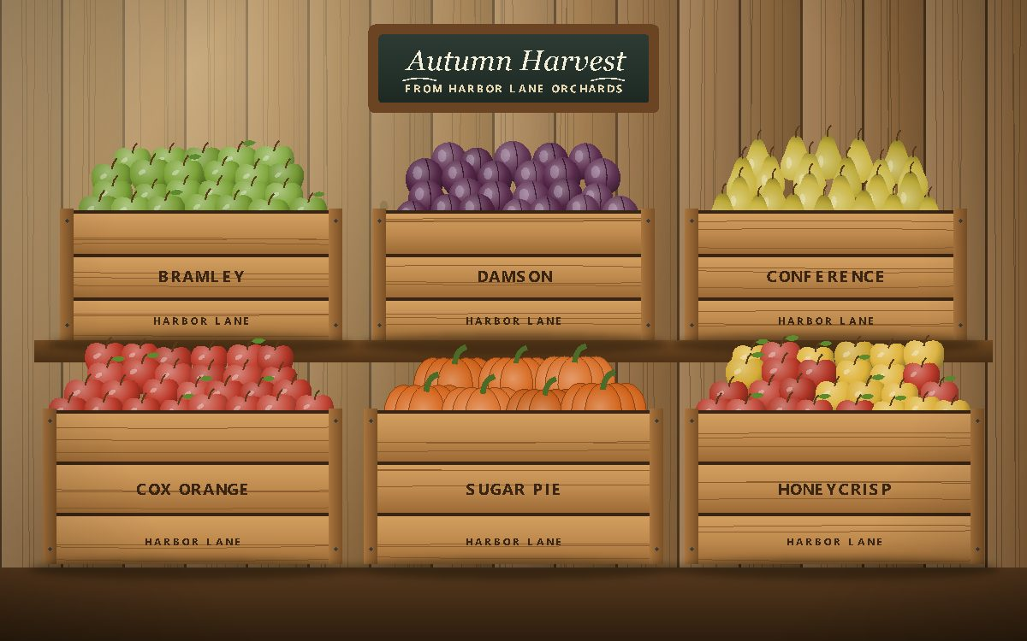

6. Payment
The Supplier invoices each delivery. The Buyer pays within 30 days of the invoice date by bank transfer.

7. Term and renewal
The agreement runs for three years and renews for one year at a time unless either party gives 90 days' written notice. Full terms: harborlane.example/terms.

8. Signatures
For Harbor Lane Provisions: Lena Park, Procurement Lead
For Northwind Coffee Roasters: Alex Chen, Head of Wholesale
Questions: lena.park@harborlane.example

